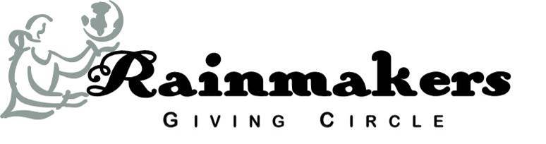

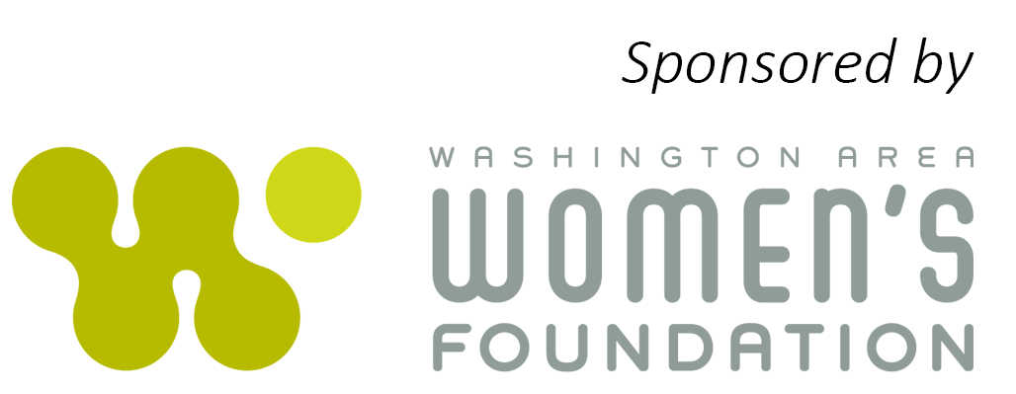

What is the Rainmakers Giving Circle?

The Rainmakers Giving Circle is a group of women who pool their money to give grants to nonprofits seeking to improve the lives of economically vulnerable girls and young women in the Washington, DC metropolitan area. Sponsored by the Washington Area Women’s Foundation, the Rainmakers select grantees whose programs are designed to empower this at-risk population by helping them become better educated and/or teaching them life skills to help them improve their self-esteem and achieve their full potential.

More specifically, the Rainmakers Giving Circle awards grants to implement programs that:
- encourage the development of healthy behaviors and the reduction of risk factors among economically vulnerable girls and young women (age 24 and under); and
- increase the competence of this target population in such areas as education, health, interpersonal relations, financial management and employment.
Members review submissions from area nonprofits responding to a Request for Proposal, determine which are worthy of a site visit, make on-site evaluations of the organizations and decide which applicants will receive funding. As a result, Rainmakers members have the opportunity to learn about many organizations in the region (and, if they wish, become more involved with them as volunteers) as well as to meet interesting women who want to give back to their communities.
Rainmakers generally operates on a two-year cycle. For each of those two years, members over age 35 commit to contribute $2,500 (or a total of $5,000), and members age 35 and under commit to contribute $1,000 (or a total of $2,000). New members who join in the second year of a cycle commit to contribute $2,500 if they are over age 35 and $1,000 if they are age 35 or under.

* * *

To date, Rainmakers has had seven successful “classes,” each consisting of 20-33 members. Rainmakers 8 began in September 2017 and will enter the second year of that cycle in September 2018.

Grants

For 15 years, Rainmakers has invested in the lives of our region’s girls and young women. To date, the Circle has awarded 70 grants totaling more than $800,000 to nonprofit organizations located in the District of Columbia, northern Virginia, Montgomery County and Prince George’s County, MD.

A breakdown of the grant-making by each “class” of the Rainmakers follows:

Rainmaker Class | Grantee | Grant Amount | Area Served
Rainmakers 8  2018 | Access Youth, Inc. | $15,000 | DC
 | HER Resiliency Center | $15,000 | DC/MD
 | Identity, Inc. | $15,000 | MD
 | Young Ladies of Tomorrow | $15,000 | DC
 | Young Playwrights’ Theater | $15,000 | DC
 | Subtotal | $75,000
Rainmakers 7  2017 | Capital Area Asset Builders | $14,000 | DC
 | Communities in Schools of the Nation’s Capital | $14,000 | DC
 | DC Scores | $14,000 | DC
 | Men Can Stop Rape | $14,000 | DC
 | Techbridge | $14,000 | DC
 | Subtotal | $70,000
Rainmakers 7 2016 | Wendt Center for Loss and Healing | $18,000 | DC
 | Amara Legal Center | $20,000 | DC
 | Bright Beginnings Child Development Center | $13,600 | DC
 | The Grassroots Project | $15,000 | DC
 | Subtotal | $66,600
 | Total Awarded by Rainmakers 7 | $136,600
Rainmakers 6 2015 | Court-Appointed Special Advocate/  Prince George’s County | $15,000 | MD
 | FAIR Girls | $15,000 | DC
 | Girls on the Run (Northern VA) | $14,050 | VA
 | Liberty’s Promise | $12,000 | MD/VA
 | Transitional Housing Corporation | $15,000 | DC
 | Subtotal | $71,050
Rainmakers 6 2014 | Court-Appointed Special Advocate/  Prince George’s County | $15,000 | MD
 | FAIR Girls | $15,000 | DC
 | Girls on the Run (Northern VA) | $14,050 | VA
 | Liberty’s Promise | $12,000 | MD/VA
 | Transitional Housing Corporation | $15,000 | DC
 | Subtotal | $71,050
 | Total Awarded by Rainmakers 6 | $142,100
Rainmakers 5 2013 | DC Abortion Fund: Healthy & Full Life Project | $18,000 | DC
 | Homeless Children's Playtime Project:  Teen Outreach Program | $12,000 | DC
 | SMYAL (Supporting and Mentoring Youth Advocates & Leaders): Women’s Leadership Institute | $14,500 | DC
 | Washington Middle School for Girls:  Graduate Support Program | $18,500 | DC
 | Subtotal | $63,000
Rainmakers 5  2012 | Crittenton Services of Greater Washington:  SNEAKERS Program | $8,200 | MD
 | DC Rape Crisis Center:  Sister Action, Sister Strength (SASS) Clubs | $10,000 | DC
 | Lydia's House: Girls: Your Money Counts | $12,000 | DC
 | SMYAL (Sexual Minority Youth Assistance League): Women’s Leadership Institute | $9,000 | DC
 | Y.O.U.R. Community Center: Petals of Primrose Leadership Program | $9,800 | DC
 | Subtotal | $49,000
 | Total Awarded by Rainmakers 5 | $112,000
Rainmakers 4 2010 | Ascensions Community Services, Inc.:  Ascending Families | $10,000 | DC
 | Capital Area Asset Builders:  College Savings for DC Youth | $12,500 | DC
 | Homeless Children's Playtime Project:  Teen Outreach Program | $11,500 | DC
 | SMYAL (Sexual Minority Youth Assistance League): Women’s Leadership Institute | $11,500 | DC
 | St. Ann’s Infant and Maternity Home:  Teen Mother-Baby Program | $9,500 | DC
 | Subtotal | $55,000
Rainmakers 4 2009 | A Wider Circle: Well Mother, Well Baby Program | $10,000 | DC/MD
 | DC Abortion Fund: Healthy & Full Life Project | $15,000 | DC
 | Kidsave: Weekend Miracles Program | $8,000 | DC
 | The Arts League: SOHO (Space of Her Own) Program | $10,000 | VA
 | The Campagna Center: LEAP Program | $12,000 | VA
 | Subtotal | $55,000
 | Total Awarded by Rainmakers 4 | $110,000
Rainmakers 3 2008 | Ascensions Community Services, Inc. | $10,000 | DC
 | Horton’s Kids, Inc. | $12,500 | DC
 | SMYAL (Sexual Minority Youth Assistance League) | $10,000 | DC
 | The Arts League: SOHO (Space of Her Own) Program | $6,000 | VA
 | The Campagna Center | $9,500 | VA
 | Subtotal | $48,000
Rainmakers 3 2007 | Girls, Inc. of the Washington DC Metropolitan Area | $10,000 | DC
 | Interstages, Inc. | $10,000 | DC
 | Prince George’s Child Resource Center | $10,000 | MD
 | SMYAL (Sexual Minority Youth Assistance League) | $10,000 | DC
 | St. Ann’s Infant and Maternity Home | $2,500 | DC/MD
 | Subtotal | $42,500
 | Total Awarded by Rainmakers 3 | $90,500
Rainmakers 2 2006 | Children’s National Medical Center:  Teen Life Clubs | $10,125 | DC
 | Interstages, Inc. | $10,125 | DC
 | Prince George’s Child Resource Center | $10,125 | MD
 | Through the Kitchen Door | $10,125 | MD
 | Subtotal | $40,500
Rainmakers 2 2005 | Tenant’s and Worker’s Support Committee | $10,000 | VA
 | Latin American Youth Center | $10,000 | DC
 | Washington Middle School for Girls | $10,000 | DC
 | Passion for Learning, Inc. | $9,500 | MD
 | Subtotal | $39,500
 | Total Awarded by Rainmakers 2 | $80,000
Rainmakers 1 2004 | The Empower Program | $8,000 | DC
 | Facilitating Leadership in Youth (FLY) | $7,000 | DC
 | Family Support Center: SISTERS | $8,000 | MD
 | Mary's Center for Maternal and Child Care | $10,000 | DC
 | Washington Middle School for Girls | $10,000 | DC
 | Wider Opportunities for Women | $7,000 | DC
 | Subtotal | $50,000
Rainmakers 1  2003 | Mary's Center for Maternal and Child Care | $10,000 | DC
 | WVSA Arts Connection-ARTiculate  Employment Training Program | $10,000 | DC
 | Florence Crittenton Services of Greater Washington: SNEAKERS Program | $10,000 | MD
 | Subtotal | $30,000
 | Total Awarded by Rainmakers 1 | $80,000
Total Awarded by Rainmakers 1 - 8 |  | $826,200

